Aadahr code : 29473237661957

Pan card : EQUPP5069J

9

Kotak Bank Details:

**Your Account Number 5913309844**

**Your CRN 359713790**

**Mishti!125**

**IFSC KKBK0000811**

**Card Number 4594 5300 4947 3762**

**CVV 673**

**Expiry 02/24**

**VPA (for UPI) 9106883632@kotak**

**Mobile Pin : 147365**

**Debit card Pin : 125896**

**Mobile no: 9586261485**

**1ĺ1tt**

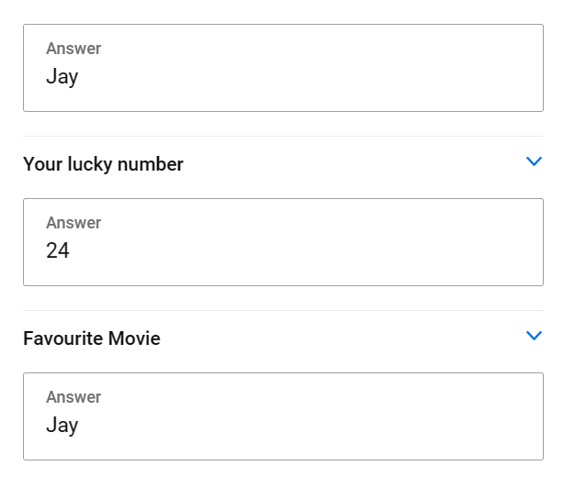



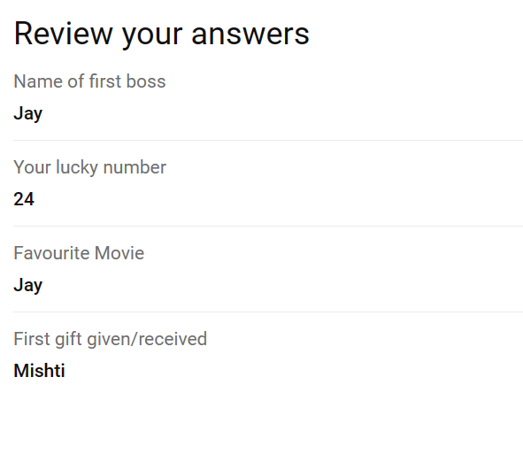

**Axis Account detail**

**Account No: 921010031884878**

**Customer ID: 907734659**

**Debit Pin: 1443**

**Internet banking: *%2fe9PX7D-yrwf**

**Hansaben Jagdishbhai Patel**

**MPIN:147365**

* **IFSC:UTIB0004410**

